Notes bibliographic Information ツ

Author(s):
Title of article or book (if a chapter in a book, put the chapter # and title here, and put the title of the book in “Title of publication”):
2016 Moratuwa Engineering Research Conference (MERCon)
Title of publication, including Vol., Num., date (if article in magazine, newspaper, or journal):

Outdoor robot navigation using Gmapping based SLAM algorithm

Page numbers (if article in magazine, newspaper, or journal):

Publisher:

Date published:

URL (if applicable):
https://ieeexplore.ieee.org/document/7480175
MLA citation:
B. L. E. A. Balasuriya et al., "Outdoor robot navigation using Gmapping based SLAM algorithm," 2016 Moratuwa Engineering Research Conference (MERCon), Moratuwa, Sri Lanka, 2016, pp. 403-408, doi: 10.1109/MERCon.2016.7480175.

‌

Direct quotes: Include Page #s (For each quote, provide some context and/or analysis; you may also want to re-state the information in your own words. Quotes from your sources, and your understanding of them, will make up the bulk of your literature review)
- “Mapping and localization are achieved in this study by using the GMapping algorithm (a variant of the SLAM algorithm) with single laser sensor. GMapping algorithm is based on Rao-Blackwellized particle filter (RBPF). As proper detection of surrounded obstacles is required for the accuracy of the algorithm, the RPLIDAR 360° laser scanner which provides both distance and bearing angle measurements to the nearby objects.”p403
- “As stated before, [the] SLAM problem takes measurements of landmark location z(k) to build the map P and to determine vehicle pose x_{v}(k) using z(k). Here, a robot with a known kinematic model starts at an unknown location and then moves through an environment containing several features or landmarks.”p404
- 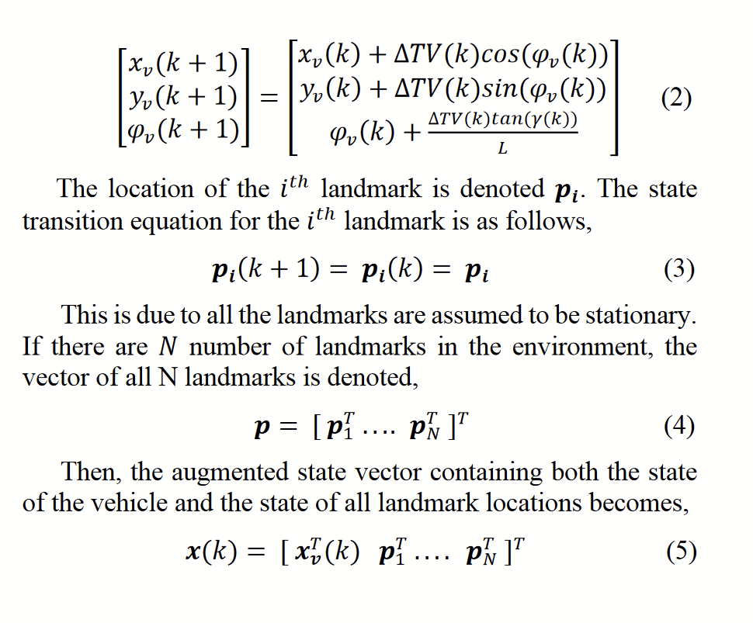(p405)
- 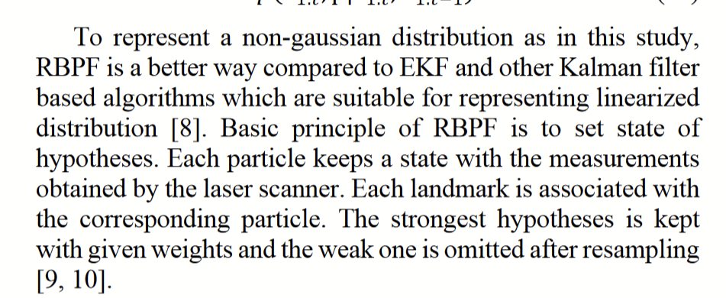(405)

- 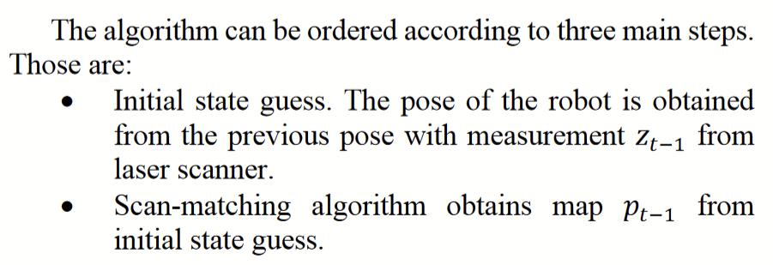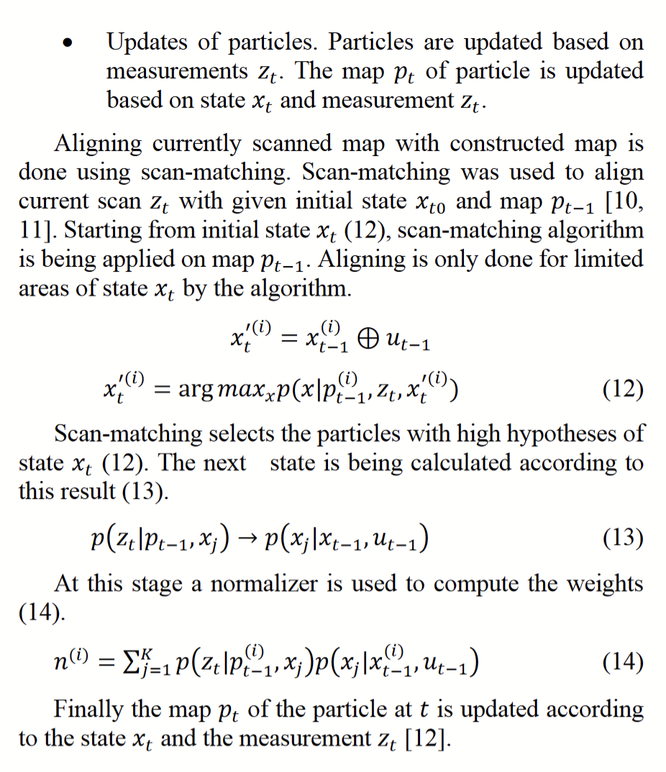(405)

Paraphrased Notes: Include Page #s (This is a space for you to track the flow of information, and the ways in which the article engages with other works.)
- Sooooo much math

Summary of Source (2-4 sentences)
GMapping assumes all objects are stationary. It takes the poses of every return from the Lidar, and adds them to a map with a confidence value. On the next laserscan it detects if the point is still there and adds or subtracts from the confidence. Once the confidence reaches a set point, it turns into a black pixel indicating that it is there. It then checks if the laserscan is the same as a previous to do loop closure.

Does this help me answer my question? Why or why not?
No, but once again it is a helpful step

Lingering Questions

Connections to other sources
S1. SLAM exists in many forms, one of which is the gmapping talked about in this article.

